Problem Statement:

AtliQ Hardware is a company which supplies computer hardware peripherals to many of the clients. They have this client called Surge stores, Nomad Stores, Excel Stores, Electricalsara Stores across India and they supply all these equipment to them . Now AtliQ hardware has a head office in Delhi and other regional offices throughout India.

Now, Bhavan Patel is a sales director for this company and he is facing a lot of challenges. One of the challenges would be about the market growth, and issues in terms of tracking the sales in this dynamically growing market. Another would be issues about the insights of his business.

He has this Regional Managers for North India, South India, and Central India. Whenever he gets insights about these three regions, he would call these people on the phone. Then these regional managers will give him some insights about what was the sales last quarter and we going to grow by this much in the next quarter.

The problem is the that, the conversation which are happening are just verbal. Based from the statement of the owner, there are this habit that all the mangers try to paint a rosy picture and try to sugar coat some things. They don’t want to look bad. When Bhavin Patel ask for an Insights , they will give him a lot of excel files like 69 files.

He is interested in getting a simple understandable digestible insight. He wants to see a dashboard where he can just open his chart and how the numbers trending.

Questions that needed to be answered:

* What are the top 4 strongest and 4 weakest stores performance by revenue in the market from 2017 to 2020?
* What are the top 4 strongest and 4 weakest stores performance by sales in the market from 2017 to 2020?
* Who are my top 5 customer leads?
* What are my top 5 products performing well?
* Provide button for me just click to ideally know what are my revenue and sales yearly, and see its respective stores performance.
* Do a trend analysis of my sales and revenue from 2017 to 2020 . Create a summary.

**Project Planning :** Using AIMS GRID and Data Discovery

|  |  |  |
| --- | --- | --- |
| Purpose | Determine the pain points.  What do we really want to do exactly? | To unlock sales insights that are not visible before for sales team for decision support and automate them to reduced manual time spend in data gathering |
| Stakeholders | Who are the people involving in this project? | Sales Director  Marketing Team  Customer Service Team  Data Analytics Team  IT |
| End Result | What do we want to achieve? | An automated dashboard providing quick and latest insights in order to support data driven decision making. |
| Success Criteria | How do we define that the project is successful? | Dashboards uncovering sales, orders, insights with latest data available.  Sales team able to take better decisions and prove 10% of cost saving of total spend  Sales Analyst stop data gathering manually in order to save 20% of their business time and reinvest it value added activity. |

**NOTES:**

Falcons (Software Engineers) owns the management system that AtliQ Hardware used. He has his sales use a management system that keeps track of all the sales number.

Whenever they sell any computer or any products in any local region, it stores the data in Falcon’s DBMS

SALES MANAGEMENT SYSTEM

MYSQL



**Data Cleaning**

* Instead of doing data cleaning in SQL. This time data will be cleaned inside the PowerBI.

Under Markets table

* Two data has no zone.

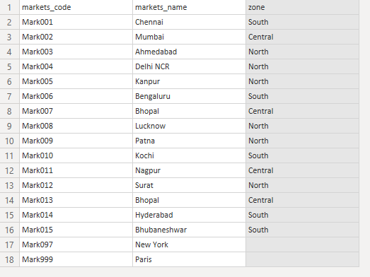

Under the transactions

* Negative sales amount and zero amount can be recovered . Thus, I will uncheck those to filter out my unnecessary data.

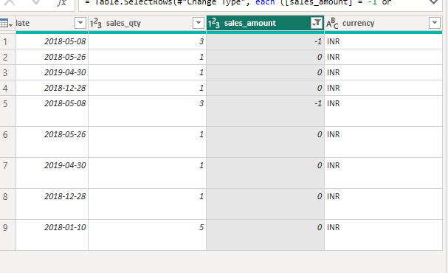

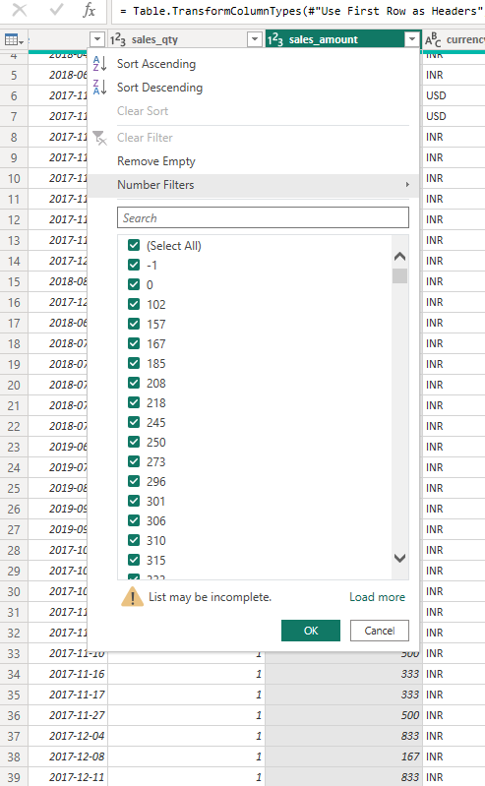

* Some data has USD currency as well. Thus, I will be replacing it with USD. Right click the value and choose replace.

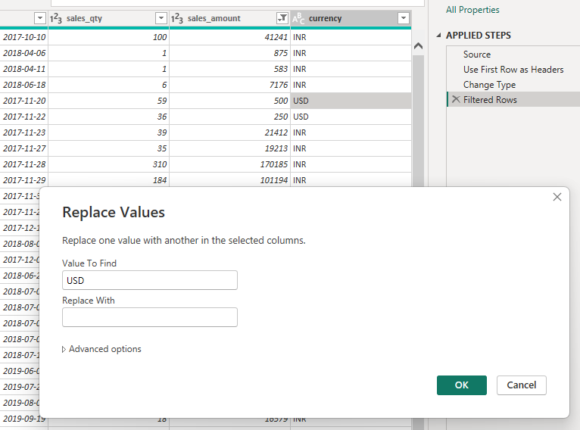

* Or use a formula “= Table.ReplaceValue(#"Filtered Rows","USD","INR",Replacer.ReplaceText,{"currency"}) “
* There are also duplicates detected via SQL. Using PowerBI, I removed all the duplicates, blank rows, and errors just to make sure that the data is clean. I applied it in all tables just to make sure as well. see images below on how I did it.

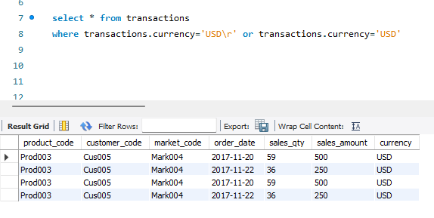

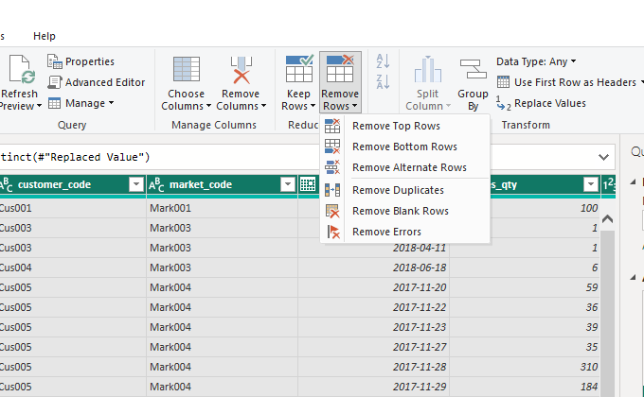

-I also have to rename some of the table columns because the data were manually imported as all csv and not through connecting MySQL database. This will just allow me to easily distinguish things up during data selection during my dashboard design.

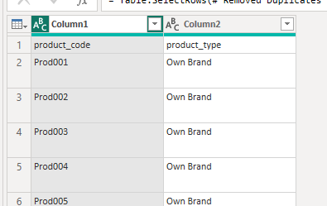

Troubleshooting

* For the year slicer. The ‘blank’ year keeps appearing. I have tried looking in transform data section but it isn’t there. There are no data that says blank either.
* So the only way to do it that I found is to filter it in the FILTERS SECTION in the report view where I am doing my dashboard. Then select “IS NOT BLANK”

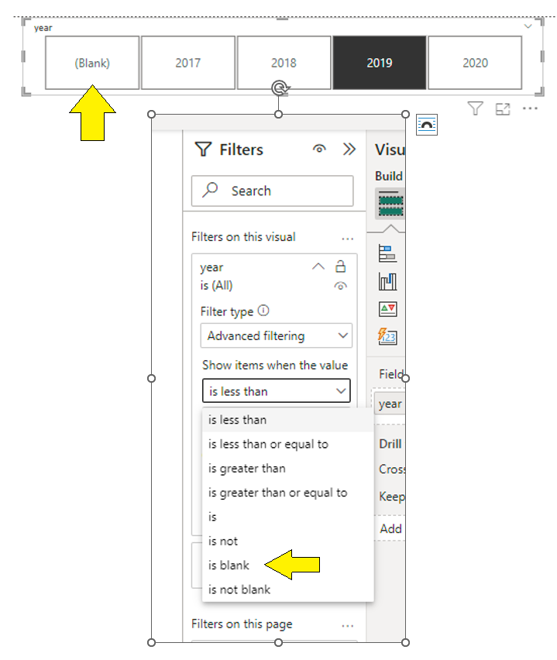

For Year Slicer Troubleshooting

* Select data view. Then select column tools then change the format of the date into (mm- yy ) for Jan 2018.
* The data is from yyyy-mm-dd transformed into mm-yy
* 1. First, select DATA View on the left side corner of the PowerBI
* 2.Second, choose the data table where you want to change the format

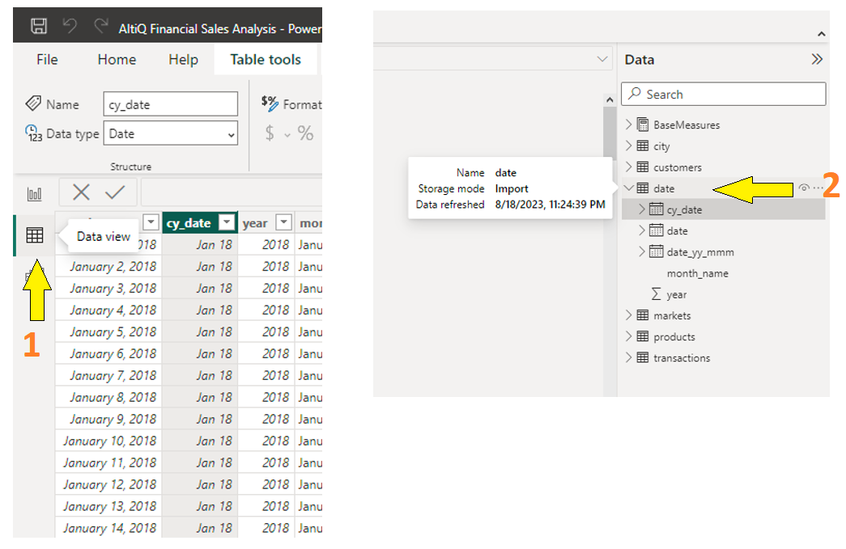

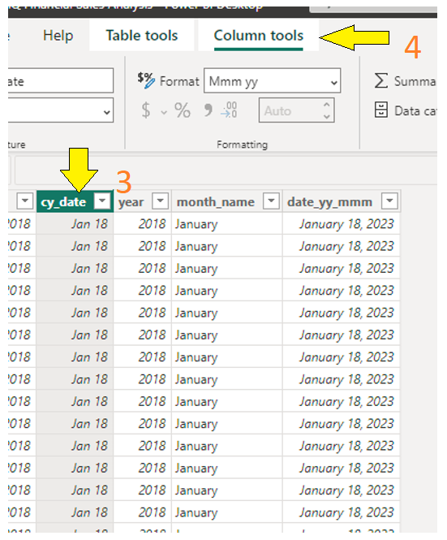



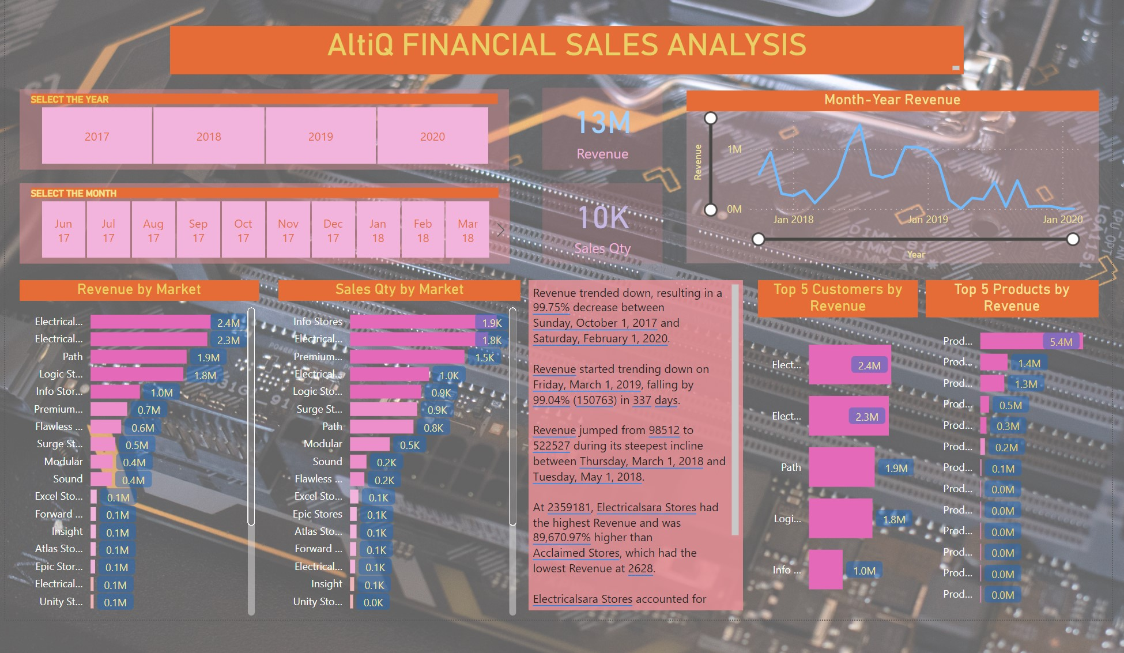

**Answers**

* What are the top 4 strongest and 4 weakest stores performance by revenue in the market from 2017 to 2020?
  + 4 strongest stores by revenue- Premium, Surge, Logic, and Sound
  + 4 weakest stores by revenue- Acclaimed, Power, Electricalslytical, Nixon
* What are the top 4 strongest and 4 weakest stores performance by sales in the market from 2017 to 2020?
  + 4 strongest stores by sales- Premium, Surge, Electricalsara, and Logic
  + 4 weakest stores by sales- Acclaimed, Power, Electricalslytical, Nixon
* Who are my top 5 customers ?
  + Top 5 Customer Leads- Premium, Surge, Logic, Sound, Electricalsara
* What are my top 5 products?
  + Top 5 Products – 003, 013, 017, 011, 001

**TREND ANALYSIS SUMMARY**

* ﻿Revenue trended up, resulting in a 373.91% increase between Monday, January 1, 2018 and Saturday, December 1, 2018.
* ﻿Revenue started trending up on Monday, January 1, 2018, rising by 373.91% (813979) in 334 days.
* Revenue jumped from 217693 to 1031672 during its steepest incline between Monday, January 1, 2018 and Saturday, December 1, 2018.
* At 1650908, Electricalslytical had the highest Revenue and was 27,124.74% higher than Electricalsquipo Stores, which had the lowest Revenue at 6064
* At 1650908, Electricalslytical had the highest Revenue and was 27,124.74% higher than Electricalsquipo Stores, which had the lowest Revenue at 6064
* At 1650908, Electricalslytical had the highest Revenue and was 27,124.74% higher than Electricalsquipo Stores, which had the lowest Revenue at 6064
* Electricalslytical accounted for 21.48% of Revenue.
* ﻿Across all 22 customer_name, Sales Qty ranged from 6 to 975.

To Request for an access to my PowerBI Dashbaord. Kindly please follow me first in github and linkedIn and click this link to motivate me to share more projects like this. Thanks for the support( <https://github.com/lois4801> , <https://www.linkedin.com/in/artemis-jay/>).